PRANAVI BADANA
PRANAVI BADANA

mailto:pranavibadana3012@gmail.com

mailto:linkedin.com/in/pranavi-badana


8897177470

mailto:https://github.com/Pranavi3012



OBJECTIVE

As a third-year Computer Science and Engineering student, I aim to join a dynamic and growth-oriented organization where I can apply my programming and development skills to contribute to real-world projects, gain industry experience, and grow into a skilled software engineer.

ACADEMIC PROFILE

Course | College/School | University/Board | Pass Out Year | Percentage  /CGPA
B.Tech. (CSE) | Aditya Institute of Technology and Management , Tekkali | JNTUGV,Vizianagaram | 2027 | 8.07 (CGPA)
Intermediate (MPC) | SR Junior College, Srikakulam | Board of Intermediate Education, Andhra Pradesh | 2023 | 90%
SSC | Vignana Durga High school, Challavanipeta | Board of Secondary Education, Andhra Pradesh | 2021 | 99%
TECHNICAL SKILLS
Programming : Basics in Python, Java, C++, PHP Development : MS Office, HTML, CSS, Java Script
Database : MySQL
Framework : Django
Tool : Google cloud
Operating Systems : Windows

Gourmet Delight – Restaurant Website
Technologies Used: HTML, CSS, JavaScript, PHP, MySQL
Developed a responsive restaurant website called Gourmet Delight to display menu items and provide an interactive user experience. Designed multiple web pages using HTML and CSS for layout and styling and for backend PHP is used. Implemented JavaScript for dynamic features such as form validation and user interaction. Integrated MySQL database to store and manage user and order details.

PROJECT EXPERIENCE
Internship Title: Prerana Mitra Intern
Organization: Government Schools – Prerana Mitra Program
Duration: 20 Weeks
Worked as a Prerana Mitra intern to support students in government schools through academic and motivational guidance.Assisted students in improving basic learning skills, confidence, and classroom participation.Helped teachers in organizing classroom activities and learning sessions.Guided students on discipline, communication skills, and career awareness.

INTERNSHIP EXPERIENCE

CERTIFICATIONS
- Completed NPTEL Certification on Cloud Computing and Distributed Systems by securing 59% which
was issued by IIT Kanpur.
- Completed NPTEL Certification on Introduction to Machine Learning .which was issued by IIT Kharagpur.

- Completed Google Gen AI study jam. Organized by the Google developer student club,AITAM.
PERSONAL DETAILS
CURRICULAR ACTIVITIES

- Participated in Technovision , which was conducted by our college.
- Securing 2nd place in the INNO TECH EXPO contest,conducted by department of CSE,AITAM.
- Participated in a java technical event “OOPs!Code it right”.

Father’s Name : B.Chinna Rao
Date of Birth : 12th June 2006
Hobbies/Interests : Drawing, making crafts and cooking
Languages Known :

Language | Speak | Read | Write
English | ✔ | ✔ | ✔
Telugu | ✔ | ✔ | ✔
Hindi |  | ✔ | ✔
DECLARATION

I hereby declare that the details furnished above are true and correct.
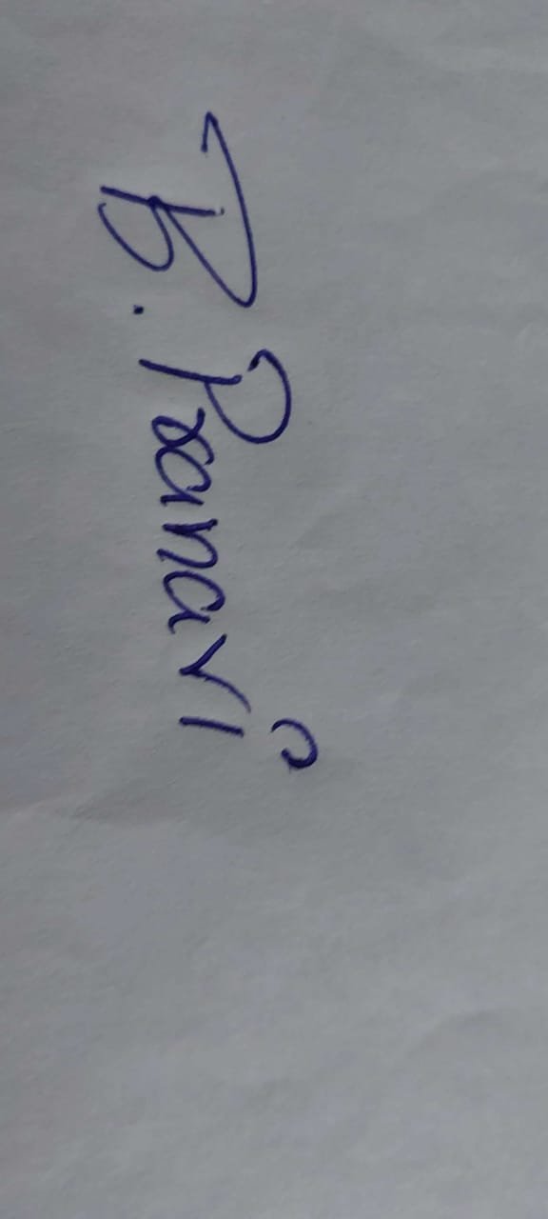
Date: 02-01-2026
Place: Tekkali (B.Pranavi)

